Source Data Mapping Approach to CDMV5.4

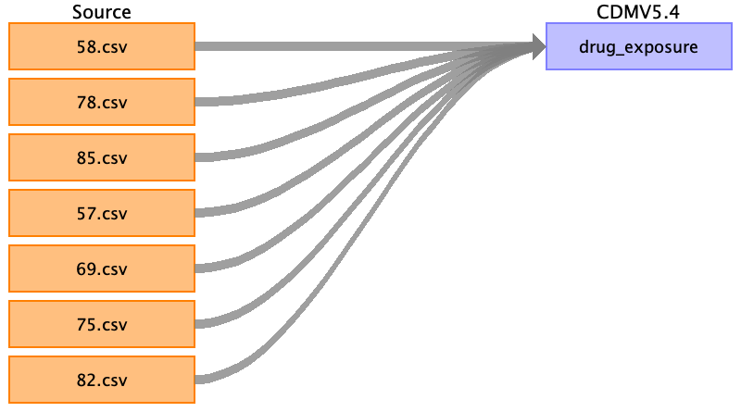

Table name: person

Table name: observation_period

Table name: visit_occurrence

Table name: visit_detail

Table name: condition_occurrence

Table name: drug_exposure

Tables 58,78,85- drug_type_concept_id-EHR 32838

Tables 57,69,75,82- drug_type_concept_id-EHR 32829

Reading from 58.csv

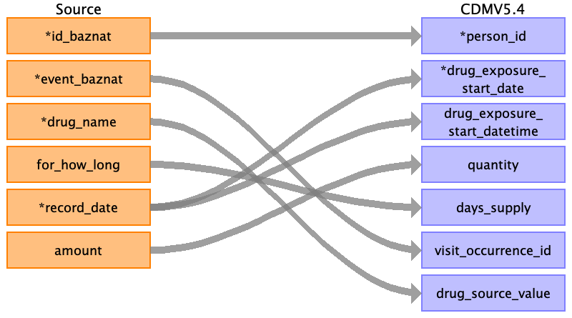

|  |  |  |  |
| --- | --- | --- | --- |
| Destination Field | Source Field | Logic | Comment |
| drug_exposure_id |  |  | Incremental auto id |
| person_id | id_baznat |  |  |
| drug_concept_id |  |  | SNOMED CODE |
| drug_exposure_start_date | record_date |  | Only date DD/MM/YYYY |
| drug_exposure_start_datetime | record_date |  | Date and time - DD/MM/YYYY HH:MM:SS |
| drug_exposure_end_date |  |  | Only date DD/MM/YYYY |
| drug_exposure_end_datetime |  |  | Date and time - DD/MM/YYYY HH:MM:SS |
| verbatim_end_date |  |  | Not use in this field. |
| drug_type_concept_id |  |  | EHR_concept_id 32838 |
| stop_reason |  |  | Not use in this field. |
| refills |  |  | Not use in this field. |
| quantity | amount |  |  |
| days_supply | for_how_long |  |  |
| sig |  |  | Not use in this field. |
| route_concept_id |  |  | Not use in this field. |
| lot_number |  |  | Not use in this field. |
| provider_id |  |  | Not use in this field-Not listed in table |
| visit_occurrence_id | event_baznat |  |  |
| visit_detail_id |  |  | Not use in this field. |
| drug_source_value | drug_name |  |  |
| drug_source_concept_id |  |  | Not use in this field. |
| route_source_value |  |  | Not use in this field. |
| dose_unit_source_value |  |  |  |

Reading from 78.csv



|  |  |  |  |
| --- | --- | --- | --- |
| Destination Field | Source Field | Logic | Comment |
| drug_exposure_id |  |  | Incremental auto id |
| person_id | id_baznat |  |  |
| drug_concept_id |  |  | SNOMED CODE |
| drug_exposure_start_date | record_date |  | Only date DD/MM/YYYY |
| drug_exposure_start_datetime | record_date |  | Date and time - DD/MM/YYYY HH:MM:SS |
| drug_exposure_end_date |  |  | Only date DD/MM/YYYY |
| drug_exposure_end_datetime |  |  | Date and time - DD/MM/YYYY HH:MM:SS |
| verbatim_end_date |  |  | Not use in this field. |
| drug_type_concept_id |  |  | EHR_concept_id 32838 |
| stop_reason |  |  | Not use in this field. |
| refills |  |  | Not use in this field. |
| quantity | amount |  |  |
| days_supply | for_how_long |  |  |
| sig |  |  | Not use in this field. |
| route_concept_id |  |  | Not use in this field. |
| lot_number |  |  | Not use in this field. |
| provider_id |  |  | Not use in this field-Not listed in table |
| visit_occurrence_id | event_baznat |  |  |
| visit_detail_id |  |  | Not use in this field. |
| drug_source_value | drug_name |  |  |
| drug_source_concept_id |  |  | Not use in this field. |
| route_source_value |  |  | Not use in this field. |
| dose_unit_source_value |  |  |  |

Reading from 85.csv

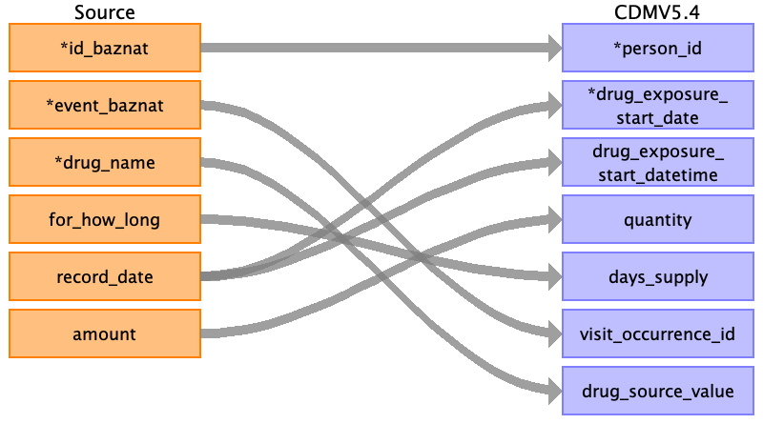

|  |  |  |  |
| --- | --- | --- | --- |
| Destination Field | Source Field | Logic | Comment |
| drug_exposure_id |  |  | Incremental auto id |
| person_id | id_baznat |  |  |
| drug_concept_id |  |  | SNOMED CODE |
| drug_exposure_start_date | record_date |  | Only date DD/MM/YYYY |
| drug_exposure_start_datetime | record_date |  | Date and time - DD/MM/YYYY HH:MM:SS |
| drug_exposure_end_date |  |  | Only date DD/MM/YYYY |
| drug_exposure_end_datetime |  |  | Date and time - DD/MM/YYYY HH:MM:SS |
| verbatim_end_date |  |  | Not use in this field. |
| drug_type_concept_id |  |  | EHR_concept_id 32838 |
| stop_reason |  |  | Not use in this field. |
| refills |  |  | Not use in this field. |
| quantity | amount |  |  |
| days_supply | for_how_long |  |  |
| sig |  |  | Not use in this field. |
| route_concept_id |  |  | Not use in this field. |
| lot_number |  |  | Not use in this field. |
| provider_id |  |  | Not use in this field-Not listed in table |
| visit_occurrence_id | event_baznat |  |  |
| visit_detail_id |  |  | Not use in this field. |
| drug_source_value | drug_name |  |  |
| drug_source_concept_id |  |  | Not use in this field. |
| route_source_value |  |  | Not use in this field. |
| dose_unit_source_value |  |  |  |

Reading from 57.csv

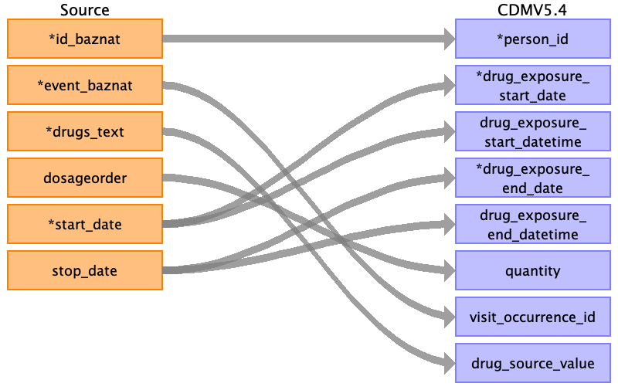

|  |  |  |  |
| --- | --- | --- | --- |
| Destination Field | Source Field | Logic | Comment |
| drug_exposure_id |  |  | Incremental auto id |
| person_id | id_baznat |  |  |
| drug_concept_id |  |  | SNOMED CODE |
| drug_exposure_start_date | start_date |  | Only date DD/MM/YYYY |
| drug_exposure_start_datetime | start_date |  | Date and time - DD/MM/YYYY HH:MM:SS |
| drug_exposure_end_date | stop_date |  | Only date DD/MM/YYYY |
| drug_exposure_end_datetime | stop_date |  | Date and time - DD/MM/YYYY HH:MM:SS |
| verbatim_end_date |  |  | Not use in this field. |
| drug_type_concept_id |  |  | EHR_concept_id 32838 |
| stop_reason |  |  | Not use in this field. |
| refills |  |  | Not use in this field. |
| quantity | dosageorder |  |  |
| days_supply |  |  |  |
| sig |  |  | Not use in this field. |
| route_concept_id |  |  | Not use in this field. |
| lot_number |  |  | Not use in this field. |
| provider_id |  |  | Not use in this field-Not listed in table |
| visit_occurrence_id | event_baznat |  |  |
| visit_detail_id |  |  | Not use in this field. |
| drug_source_value | drugs_text |  |  |
| drug_source_concept_id |  |  | Not use in this field. |
| route_source_value |  |  | Not use in this field. |
| dose_unit_source_value |  |  |  |

Reading from 69.csv



|  |  |  |  |
| --- | --- | --- | --- |
| Destination Field | Source Field | Logic | Comment |
| drug_exposure_id |  |  | Incremental auto id |
| person_id | id_baznat |  |  |
| drug_concept_id |  |  | SNOMED CODE |
| drug_exposure_start_date | start_date |  | Only date DD/MM/YYYY |
| drug_exposure_start_datetime | start_date |  | Date and time - DD/MM/YYYY HH:MM:SS |
| drug_exposure_end_date | stop_date |  | Only date DD/MM/YYYY |
| drug_exposure_end_datetime | stop_date |  | Date and time - DD/MM/YYYY HH:MM:SS |
| verbatim_end_date |  |  | Not use in this field. |
| drug_type_concept_id |  |  | EHR_concept_id 32838 |
| stop_reason |  |  | Not use in this field. |
| refills |  |  | Not use in this field. |
| quantity | dosageorder |  |  |
| days_supply |  |  |  |
| sig |  |  | Not use in this field. |
| route_concept_id |  |  | Not use in this field. |
| lot_number |  |  | Not use in this field. |
| provider_id |  |  | Not use in this field-Not listed in table |
| visit_occurrence_id | event_baznat |  |  |
| visit_detail_id |  |  | Not use in this field. |
| drug_source_value | drugs_text |  |  |
| drug_source_concept_id |  |  | Not use in this field. |
| route_source_value |  |  | Not use in this field. |
| dose_unit_source_value |  |  |  |

Reading from 75.csv



|  |  |  |  |
| --- | --- | --- | --- |
| Destination Field | Source Field | Logic | Comment |
| drug_exposure_id |  |  | Incremental auto id |
| person_id | id_baznat |  |  |
| drug_concept_id |  |  | SNOMED CODE |
| drug_exposure_start_date | start_date |  | Only date DD/MM/YYYY |
| drug_exposure_start_datetime | start_date |  | Date and time - DD/MM/YYYY HH:MM:SS |
| drug_exposure_end_date | stop_date |  | Only date DD/MM/YYYY |
| drug_exposure_end_datetime | stop_date |  | Date and time - DD/MM/YYYY HH:MM:SS |
| verbatim_end_date |  |  | Not use in this field. |
| drug_type_concept_id |  |  | EHR_concept_id 32838 |
| stop_reason |  |  | Not use in this field. |
| refills |  |  | Not use in this field. |
| quantity | dosageorder |  |  |
| days_supply |  |  |  |
| sig |  |  | Not use in this field. |
| route_concept_id |  |  | Not use in this field. |
| lot_number |  |  | Not use in this field. |
| provider_id |  |  | Not use in this field-Not listed in table |
| visit_occurrence_id | event_baznat |  |  |
| visit_detail_id |  |  | Not use in this field. |
| drug_source_value | drugs_text |  |  |
| drug_source_concept_id |  |  | Not use in this field. |
| route_source_value |  |  | Not use in this field. |
| dose_unit_source_value |  |  |  |

Reading from 82.csv



|  |  |  |  |
| --- | --- | --- | --- |
| Destination Field | Source Field | Logic | Comment |
| drug_exposure_id |  |  | Incremental auto id |
| person_id | id_baznat |  |  |
| drug_concept_id |  |  | SNOMED CODE |
| drug_exposure_start_date | start_date |  | Only date DD/MM/YYYY |
| drug_exposure_start_datetime | start_date |  | Date and time - DD/MM/YYYY HH:MM:SS |
| drug_exposure_end_date | stop_date |  | Only date DD/MM/YYYY |
| drug_exposure_end_datetime | stop_date |  | Date and time - DD/MM/YYYY HH:MM:SS |
| verbatim_end_date |  |  | Not use in this field. |
| drug_type_concept_id |  |  | EHR_concept_id 32838 |
| stop_reason |  |  | Not use in this field. |
| refills |  |  | Not use in this field. |
| quantity | dosageorder |  |  |
| days_supply |  |  |  |
| sig |  |  | Not use in this field. |
| route_concept_id |  |  | Not use in this field. |
| lot_number |  |  | Not use in this field. |
| provider_id |  |  | Not use in this field-Not listed in table |
| visit_occurrence_id | event_baznat |  |  |
| visit_detail_id |  |  | Not use in this field. |
| drug_source_value | drugs_text |  |  |
| drug_source_concept_id |  |  | Not use in this field. |
| route_source_value |  |  | Not use in this field. |
| dose_unit_source_value |  |  |  |

Table name: procedure_occurrence

Table name: device_exposure

Table name: measurement

Table name: observation

Table name: death

Table name: note

Table name: note_nlp

Table name: specimen

Table name: fact_relationship

Table name: location

Table name: care_site

Table name: provider

Table name: payer_plan_period

Table name: cost

Table name: drug_era

Table name: dose_era

Table name: condition_era

Table name: episode

Table name: episode_event

Table name: metadata

Table name: cdm_source

Table name: cohort

Table name: cohort_definition

Appendix: source tables

Table: book1.csv

|  |  |  |  |
| --- | --- | --- | --- |
| Field | Type | Most freq. value | Comment |

Table: 58.csv

|  |  |  |  |
| --- | --- | --- | --- |
| Field | Type | Most freq. value | Comment |
| id_baznat | INT |  |  |
| event_baznat | INT |  |  |
| drug_name | VARCHAR |  |  |
| for_how_long | REAL |  |  |
| record_date | VARCHAR |  |  |
| amount | VARCHAR |  |  |

Table: 78.csv

|  |  |  |  |
| --- | --- | --- | --- |
| Field | Type | Most freq. value | Comment |
| id_baznat | INT |  |  |
| event_baznat | INT |  |  |
| drug_name | VARCHAR |  |  |
| for_how_long | REAL |  |  |
| record_date | VARCHAR |  |  |
| amount | VARCHAR |  |  |

Table: 85.csv

|  |  |  |  |
| --- | --- | --- | --- |
| Field | Type | Most freq. value | Comment |
| id_baznat | INT |  |  |
| event_baznat | INT |  |  |
| drug_name | VARCHAR |  |  |
| for_how_long | REAL |  |  |
| record_date | VARCHAR |  |  |
| amount | VARCHAR |  |  |

Table: 57.csv

|  |  |  |  |
| --- | --- | --- | --- |
| Field | Type | Most freq. value | Comment |
| id_baznat | INT |  |  |
| event_baznat | INT |  |  |
| drugs_text | VARCHAR |  |  |
| dosageorder | VARCHAR |  |  |
| start_date | VARCHAR |  |  |
| stop_date | VARCHAR |  |  |

Table: 69.csv

|  |  |  |  |
| --- | --- | --- | --- |
| Field | Type | Most freq. value | Comment |
| id_baznat | INT |  |  |
| event_baznat | INT |  |  |
| drugs_text | VARCHAR |  |  |
| dosageorder | VARCHAR |  |  |
| start_date | VARCHAR |  |  |
| stop_date | VARCHAR |  |  |

Table: 75.csv

|  |  |  |  |
| --- | --- | --- | --- |
| Field | Type | Most freq. value | Comment |
| id_baznat | INT |  |  |
| event_baznat | INT |  |  |
| drugs_text | VARCHAR |  |  |
| dosageorder | VARCHAR |  |  |
| start_date | VARCHAR |  |  |
| stop_date | VARCHAR |  |  |

Table: 82.csv

|  |  |  |  |
| --- | --- | --- | --- |
| Field | Type | Most freq. value | Comment |
| id_baznat | INT |  |  |
| event_baznat | INT |  |  |
| drugs_text | VARCHAR |  |  |
| dosageorder | VARCHAR |  |  |
| start_date | VARCHAR |  |  |
| stop_date | VARCHAR |  |  |